**Assignment 7.1**

**7.1) Calculate the number of employees corresponding to each skill from the table 'employee' which is**

**loaded in the Demo.**

**Step 1: First we have to create a table with all the attribute and there datatype .**

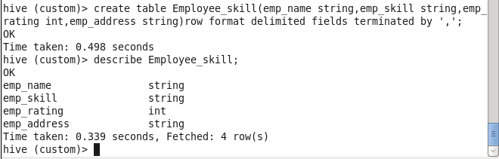

**After that we will load the dataset on the same table that we have created on the hive.**

**Can see and check weather table is created with the data or not using**

**Command: Select * from Employee_skill.**

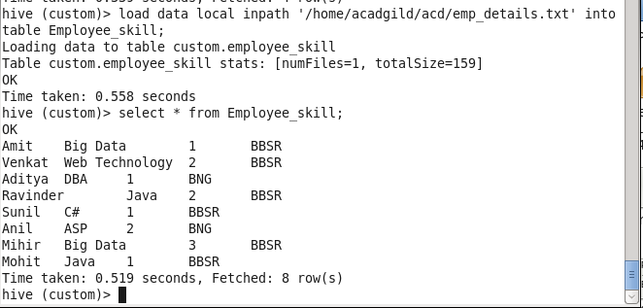

**Step2: Will use the query given below for the above question.**

**Query: select count(emp_skill)from Employee_skill group by emp_skill;**

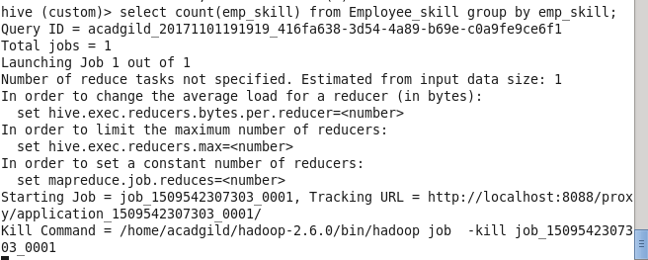

**This will be the desired output we will get on running the query.**

